MySQL for Beginners
Building a Blog Application Database
A Practical Step-by-Step Guide for Complete Beginners
🗄️ MySQL Workbench · Four Tables · Full SQL Commands

Introduction
Welcome me! By the end of this guide you will have built a fully working blogging database inside MySQL Workbench — completely from scratch. Every SQL command is shown in full so you can simply copy, type, and run it.

This guide assumes you have never used MySQL before. Every new concept is explained in plain English before you encounter it.

What We Are Building
We will create a database for a simple blog application that supports:
- Users — people who sign up to the blog
- Posts — articles written by users (with a title, description and image)
- Comments — other users can reply to posts
- Likes — users can like posts

Key Concepts — Plain English Glossary
Before writing a single line of SQL, make sure you understand these eight ideas. Return here whenever something feels confusing.

Term | What it means
Database | The container that holds your whole project. Think of it as a filing cabinet.
Table | Stores one type of thing — like a spreadsheet tab. Our project has 4 tables: users, posts, comments, likes.
Row | One record inside a table. One user = one row. One post = one row.
Column | One field in a table. For example, the email column stores every user's email address.
Primary Key (PK) | A unique ID for every row. No two rows can share the same PK. MySQL uses it to find rows instantly.
Foreign Key (FK) | A column that points to the PK of another table. It is how tables link to each other.
One-to-Many | One user can write many posts. The 'one' side holds no FK; the 'many' side stores the FK back to the 'one'.
Many-to-Many | Many users can like many posts. Because neither side can store the FK directly, we use a separate 'junction' table (our likes table).

💡 Why do we need foreign keys?
A foreign key enforces referential integrity — it prevents you from saving a post for a user that does not exist. MySQL will reject the INSERT and give you an error. This is a good thing!

Database Schema — What We Are Creating
Below are the four tables, their columns, and their data types. Study this before writing any SQL — it is your blueprint.

📋 users
Column Name | Type | Notes
user_id | INT | PK · AUTO_INCREMENT · unique per user  INT stands for integer = whole numbers only.
username | VARCHAR(50) | NOT NULL — required field  VARCHAR(50) stands for variable characters (50) = text up to 50 characters
email | VARCHAR(100) | NOT NULL · UNIQUE — no duplicates allowed!
created_at | TIMESTAMP | Set automatically when the row is inserted  TIMESTAMP means date & time. 2024-03-31 10:45:00

📋 posts
Column Name | Type | Notes
post_id | INT | PK · AUTO_INCREMENT
user_id | INT | FK → users.user_id — who wrote this post
title | VARCHAR(150) | NOT NULL
description | TEXT | NOT NULL — long text field  TEXT stands for very long text = (no set limit). It’s good for blog post descriptions.
image_url | VARCHAR(255) | Optional — can be NULL
created_at | TIMESTAMP | Auto-set on insert
updated_at | TIMESTAMP | Auto-updated whenever the row changes

📋 comments
Column Name | Type | Notes
comment_id | INT | PK · AUTO_INCREMENT
post_id | INT | FK → posts.post_id — which post this comment is on
user_id | INT | FK → users.user_id — who wrote this comment
comment_text | TEXT | NOT NULL
created_at | TIMESTAMP | Auto-set on insert

📋 likes
Column Name | Type | Notes
user_id | INT | FK → users.user_id (part of composite PK)
post_id | INT | FK → posts.post_id (part of composite PK)
created_at | TIMESTAMP | Auto-set on insert

💡 What is a Composite Primary Key?
The likes table has NO single unique ID column. Instead, the pair (user_id + post_id) is unique. This automatically prevents the same user from liking the same post twice. MySQL will reject a duplicate with an error.

Step-by-Step Instructions
Follow every step in order. Do not skip steps — later steps depend on earlier ones.

Step 1 Open MySQL Workbench
Launch MySQL Workbench from your Applications or Start Menu. You will see the Home screen with a list of connections.

💡 No connection yet?
Click the + icon next to 'MySQL Connections'. Set Hostname to 127.0.0.1, Port to 3306, and Username to root. Click 'Test Connection' — if it succeeds, click OK.

Step 2 Connect to Your Local MySQL Server
On the Home screen, double-click your local connection (usually called 'Local instance MySQL' or similar). Enter your password when prompted. You will land in the main editor window.

Step 3 Open a New SQL Query Tab
At the top of the editor, click the small
+ icon next to the query tab area, or go to File → New Query Tab. A blank white text area will appear. This is where you will type all your SQL commands.
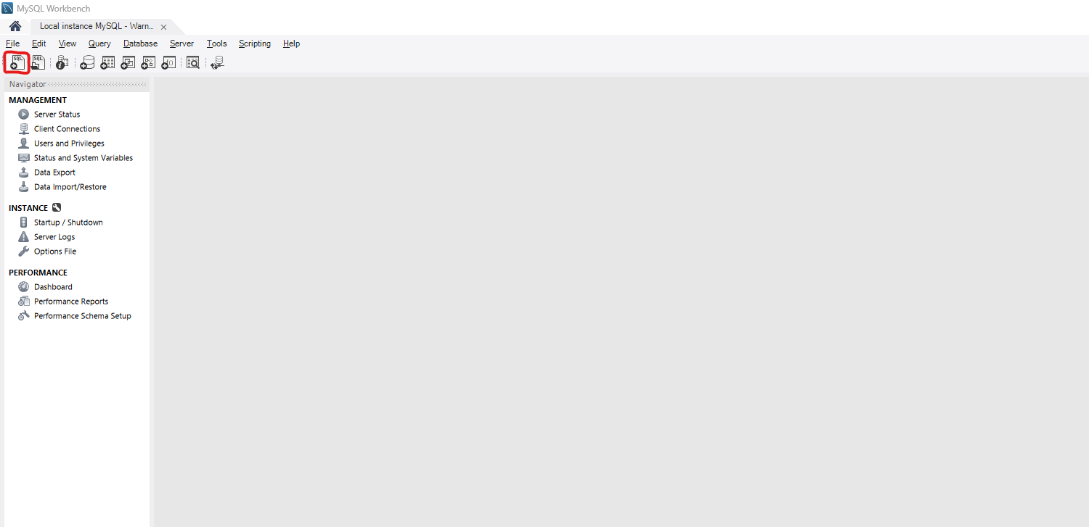

💡 Running a command
Type your SQL, then click the yellow lightning bolt ⚡ button (or press Ctrl+Enter / Cmd+Enter on Mac). The Results panel at the bottom will show success or error messages.

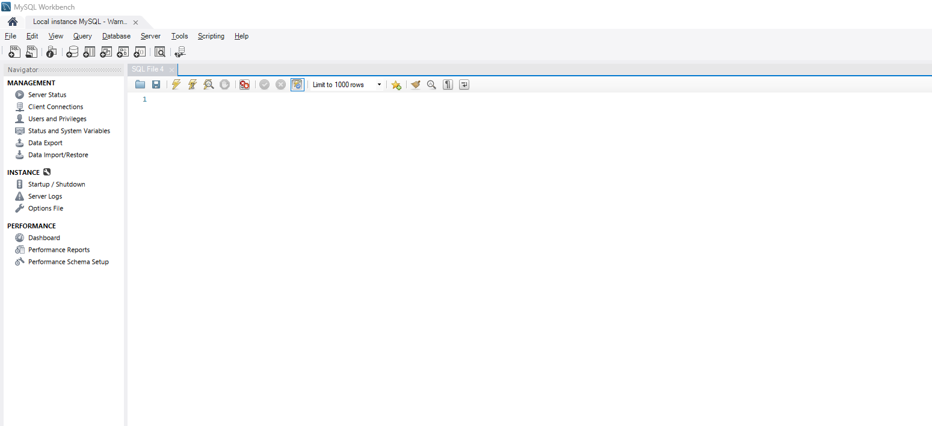
Step 4 Create the Database
Type the following command and run it:

CREATE DATABASE blog_app;

If it works, you will see 1 row(s) affected in the Output panel at the bottom. MySQL has created an empty database called blog_app.

⚠️ Case sensitivity tip
SQL keywords like CREATE, DATABASE, TABLE are not case-sensitive, but it is best practice to write them in UPPERCASE so they stand out from your table and column names.

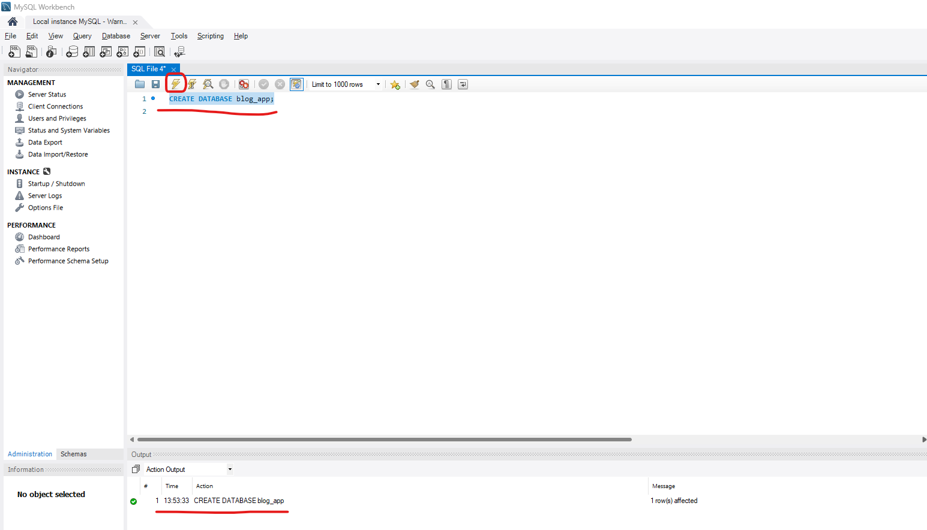
Step 5 Tell MySQL to Use Your New Database
Every SQL command you run from now on must target the correct database. Run:

USE blog_app;

This is like opening the right filing cabinet drawer. Without this step, MySQL does not know which database to put your tables in.
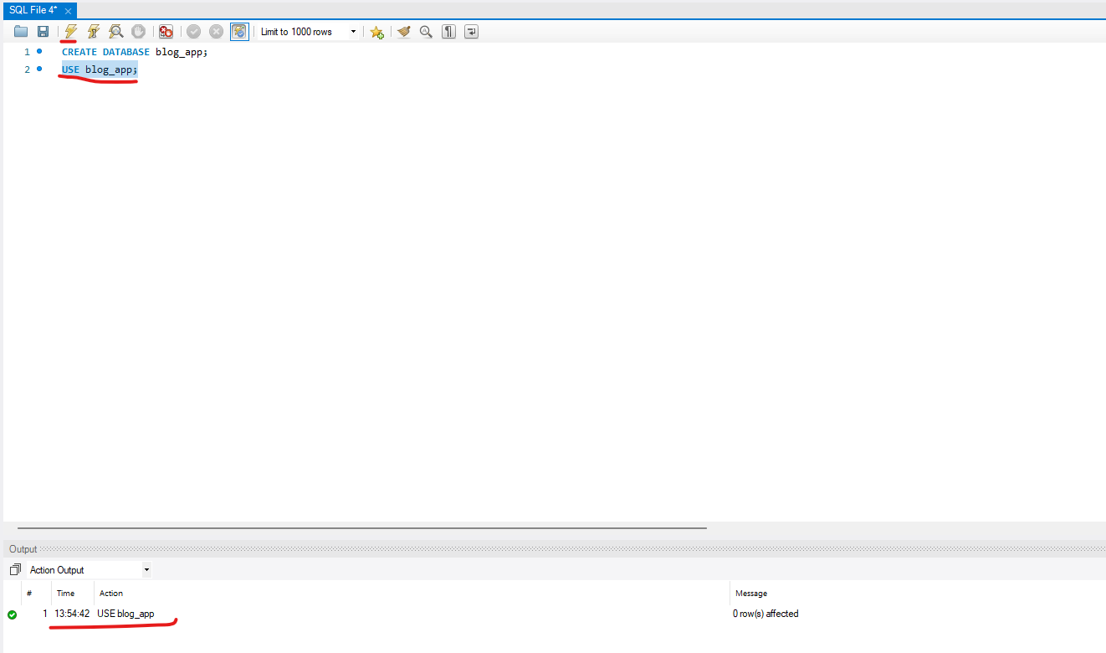

Step 6 Create the users Table
Run the following command:

CREATE TABLE users (
user_id INT AUTO_INCREMENT PRIMARY KEY,
username VARCHAR(50) NOT NULL,
email VARCHAR(100) NOT NULL UNIQUE,
created_at TIMESTAMP DEFAULT CURRENT_TIMESTAMP
);

What each line means:
- user_id INT AUTO_INCREMENT PRIMARY KEY — MySQL automatically generates 1, 2, 3 … for each new user. PRIMARY KEY means no two rows can share this value.
- username VARCHAR(50) NOT NULL — A text field up to 50 characters. NOT NULL means it is required.
- email VARCHAR(100) NOT NULL UNIQUE — UNIQUE means two users cannot have the same email address.
- created_at TIMESTAMP DEFAULT CURRENT_TIMESTAMP — MySQL fills this in automatically with the current date and time.
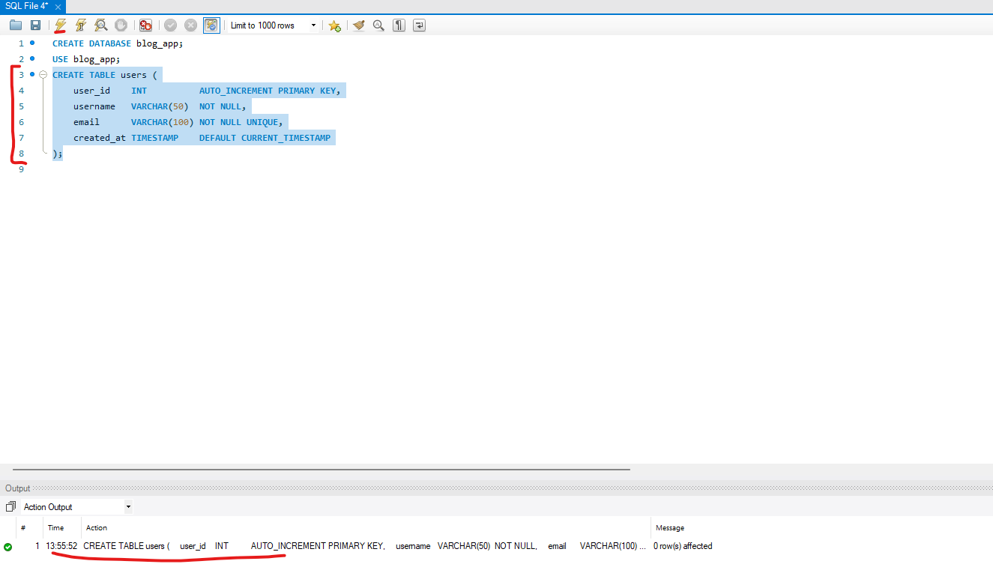

Step 7 Create the posts Table
Run the following command:

CREATE TABLE posts (
post_id INT AUTO_INCREMENT PRIMARY KEY,
user_id INT NOT NULL,
title VARCHAR(150) NOT NULL,
description TEXT NOT NULL,
image_url VARCHAR(255),
created_at TIMESTAMP DEFAULT CURRENT_TIMESTAMP,
updated_at TIMESTAMP DEFAULT CURRENT_TIMESTAMP
ON UPDATE CURRENT_TIMESTAMP,
CONSTRAINT fk_posts_user
FOREIGN KEY (user_id) REFERENCES users(user_id)
);

What is new here:
- user_id INT NOT NULL — This stores which user wrote the post. It is a foreign key pointing to users.user_id.
- TEXT — Unlike VARCHAR, TEXT can store very long strings with no fixed limit — perfect for post descriptions.
- image_url VARCHAR(255) — No NOT NULL here, so this field is optional (it can be NULL).
- updated_at … ON UPDATE CURRENT_TIMESTAMP — MySQL automatically updates this timestamp whenever the row is edited.
- CONSTRAINT fk_posts_user FOREIGN KEY … — This is the link that enforces the relationship. MySQL will reject any post whose user_id does not exist in the users table.

💡 What is a CONSTRAINT?
A CONSTRAINT is a rule enforced by MySQL at the database level. Naming the constraint (fk_posts_user) makes it easy to identify in error messages and drop it later if needed.
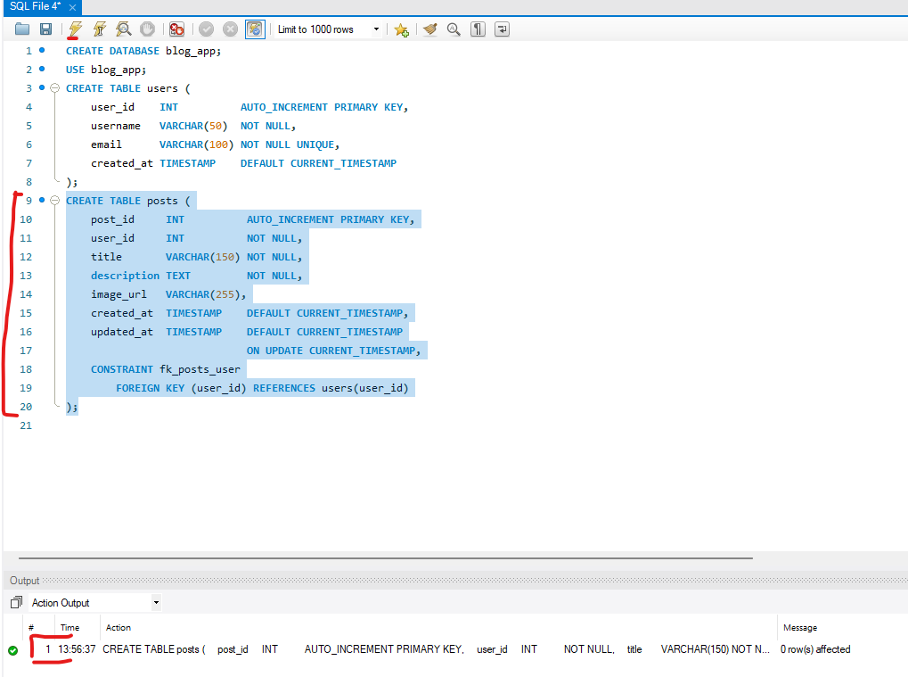
Step 8 Create the comments Table
Run the following command:

CREATE TABLE comments (
comment_id INT AUTO_INCREMENT PRIMARY KEY,
post_id INT NOT NULL,
user_id INT NOT NULL,
comment_text TEXT NOT NULL,
created_at TIMESTAMP DEFAULT CURRENT_TIMESTAMP,
CONSTRAINT fk_comments_post
FOREIGN KEY (post_id) REFERENCES posts(post_id),
CONSTRAINT fk_comments_user
FOREIGN KEY (user_id) REFERENCES users(user_id)
);

Why does this table have two foreign keys?
A comment belongs to both:
- The post it was written on (post_id → posts.post_id)
- The user who wrote it (user_id → users.user_id)

Without both foreign keys, you would not know which post the comment belongs to, or who left it.

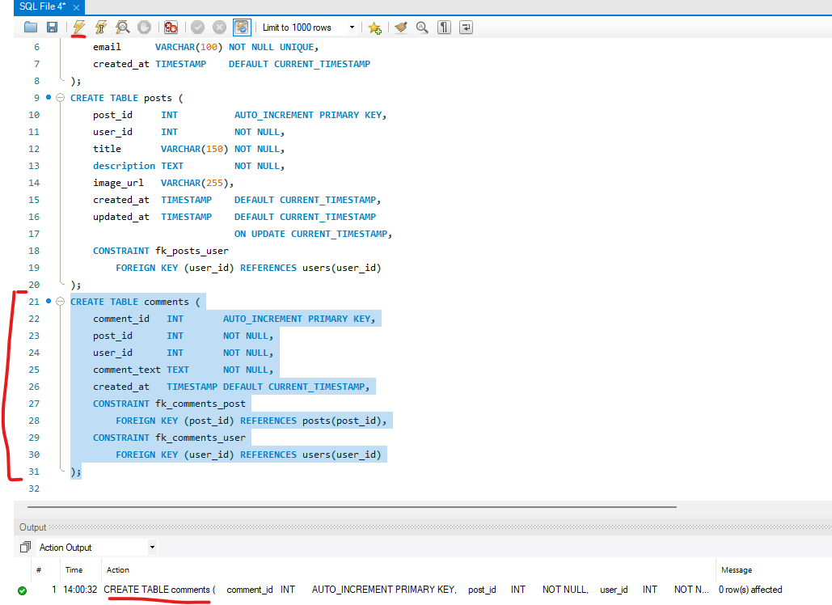
Step 9 Create the likes Table
Run the following command:

CREATE TABLE likes (
user_id INT NOT NULL,
post_id INT NOT NULL,
created_at TIMESTAMP DEFAULT CURRENT_TIMESTAMP,
PRIMARY KEY (user_id, post_id),
CONSTRAINT fk_likes_user
FOREIGN KEY (user_id) REFERENCES users(user_id),
CONSTRAINT fk_likes_post
FOREIGN KEY (post_id) REFERENCES posts(post_id)
);

The composite primary key explained:
Notice PRIMARY KEY (user_id, post_id) — the primary key is made of two columns together. The pair must be unique. So the same user cannot like the same post twice. MySQL will block it automatically with an error.
💡 Why no auto-increment ID here?
Unlike users, posts and comments, a 'like' has no meaning outside the combination of who liked what. So we use the natural pair (user_id, post_id) as the primary key instead of inventing a separate ID.
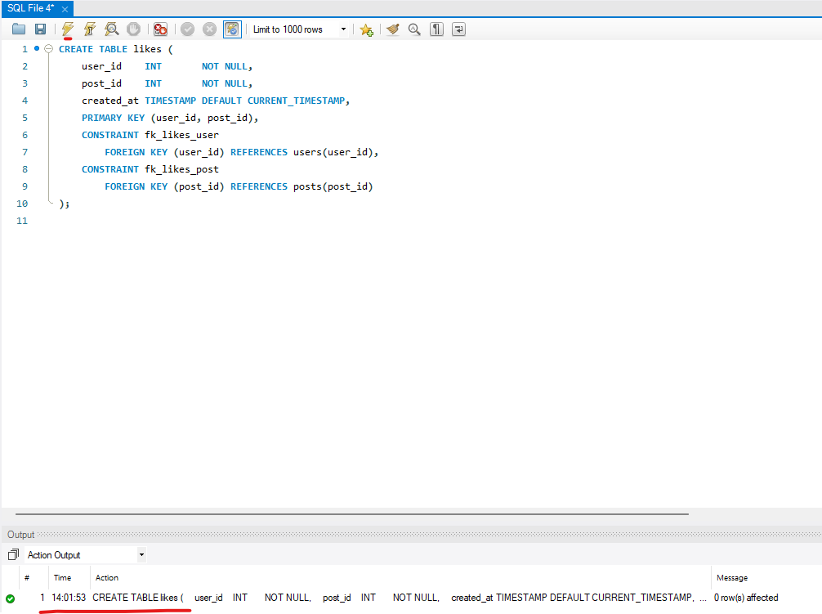
Step 10 Verify Your Tables in the Navigator
Look at the Navigator panel on the left side of Workbench. Expand Schemas → blog_app → Tables. You should now see four tables:

- users
- posts
- comments
- likes

If you cannot see them yet, right-click on the Schemas panel and click Refresh All.

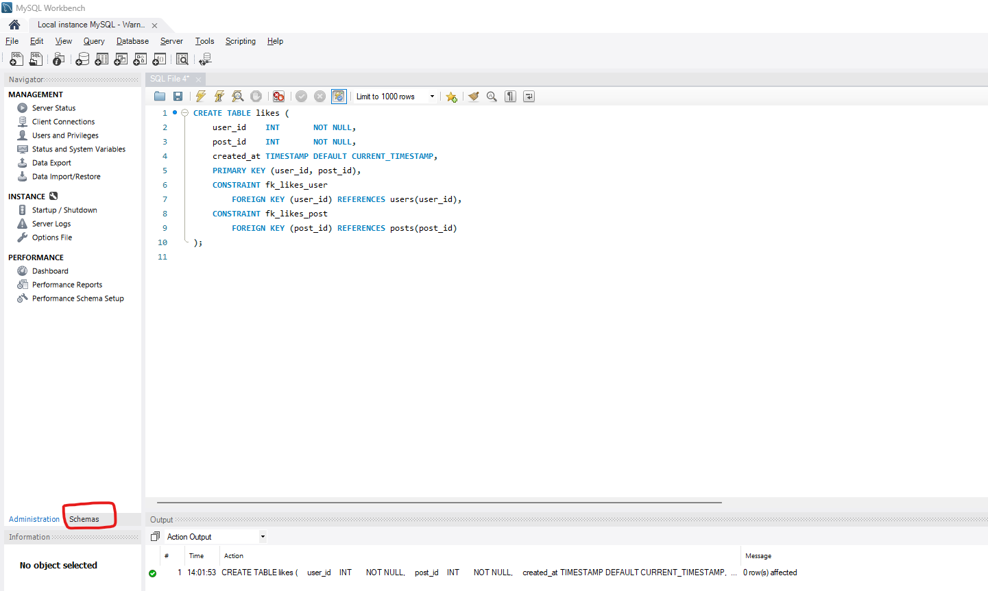
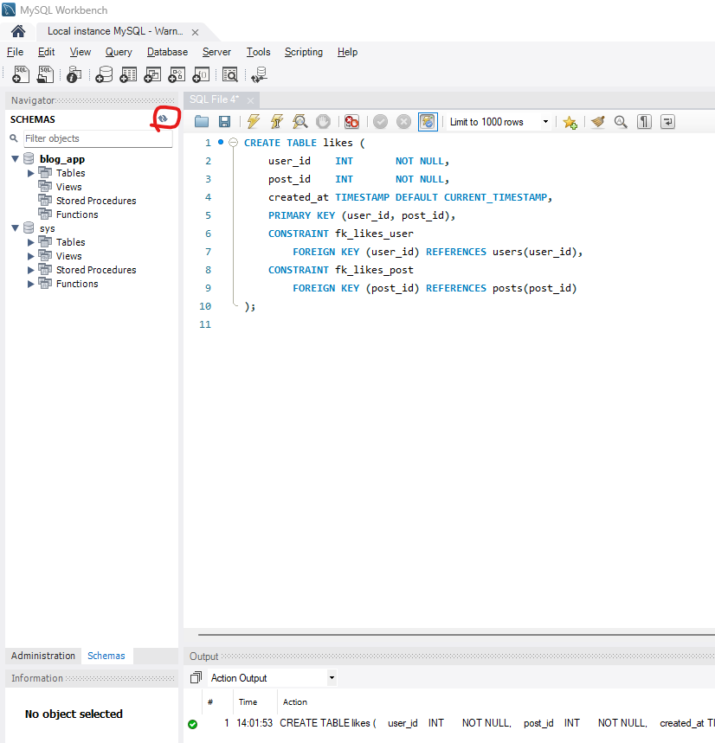
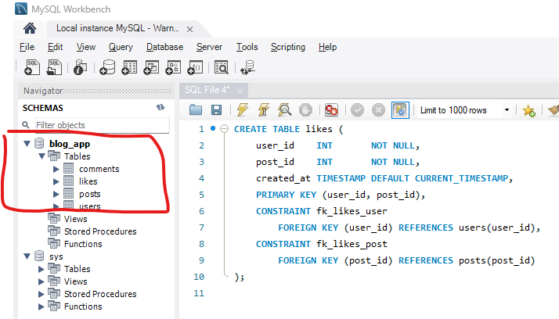

Step 11 Insert Sample Users
Now let's add some test data. Run:

INSERT INTO users (username, email)
VALUES
('alice', 'alice@example.com'),
('bob', 'bob@example.com'),
('maya', 'maya@example.com');

Notice we do not insert user_id or created_at — MySQL fills those in automatically thanks to AUTO_INCREMENT and DEFAULT CURRENT_TIMESTAMP.

Step 12 Check Your Users
Run a SELECT to read back what you just inserted:

SELECT * FROM users;

You should see a table of 3 rows in the Results panel, with user_id values 1, 2, and 3 filled in automatically.

💡 What does SELECT * mean?
SELECT = retrieve rows. * = all columns. FROM users = from the users table. It is the most fundamental SQL query you will ever write.

Step 13 Insert Sample Posts
Now insert some posts. Note we reference user_id values 1 (alice) and 3 (maya):

INSERT INTO posts (user_id, title, description, image_url)
VALUES
(1, 'My First Blog Post',
'This is my first post on the blog.',
'https://example.com/image1.jpg'),
(1, 'Learning SQL Basics',
'Today I learned about tables, keys and relationships.',
'https://example.com/image2.jpg'),
(3, 'Why Data Models Matter',
'A good data model makes apps easier to build.',
NULL);

The third post uses NULL for image_url — this is fine because we did not put NOT NULL on that column.

Step 14 Check Your Posts
SELECT * FROM posts;

Confirm you see 3 rows. Notice updated_at and created_at were set automatically.

Step 15 Insert Sample Comments

INSERT INTO comments (post_id, user_id, comment_text)
VALUES
(1, 2, 'Great first post!'),
(1, 3, 'Thanks for sharing this.'),
(3, 1, 'This explanation helped a lot.');

Here bob (user_id 2) and maya (user_id 3) comment on alice's first post. Alice (user_id 1) comments on maya's post.

Step 16 Insert Sample Likes

INSERT INTO likes (user_id, post_id)
VALUES
(2, 1),
(3, 1),
(1, 3);

Bob and Maya like alice's first post. Alice likes maya's post.

Step 17 Check Your Comments and Likes
SELECT * FROM comments;
SELECT * FROM likes;

Run both queries. You should see 3 rows in each result.

Step 18 Test the Duplicate Like Rule
Try to insert a like that already exists:

INSERT INTO likes (user_id, post_id)
VALUES (2, 1);

This should fail. You will see an error similar to: ERROR 1062 (23000): Duplicate entry '2-1' for key 'PRIMARY'

💡 Why is this error a good thing?
The composite primary key (user_id, post_id) is doing its job. It is impossible for the same user to like the same post twice. MySQL enforces this automatically — you never have to write code to check for it.

Querying Your Data — SELECT Statements
Now that data is in the database, let's learn how to read it back in useful ways.

Step 19 View All Posts With Their Authors — JOIN
This query combines two tables to show post titles alongside the username of the person who wrote them:

SELECT
posts.post_id,
posts.title,
users.username AS author
FROM posts
JOIN users ON posts.user_id = users.user_id;

What is a JOIN?
A JOIN combines rows from two tables where a matching value is found. Here we match posts.user_id with users.user_id. Without JOIN, you would get a list of posts but not know who wrote them.

AS author is an alias — it renames the username column in the result to 'author' so the output is easier to read.

Step 20 View All Comments on a Specific Post
This shows all comments on post number 1, including the commenter's username:

SELECT
comments.comment_id,
comments.comment_text,
users.username AS commenter,
comments.created_at
FROM comments
JOIN users ON comments.user_id = users.user_id
WHERE comments.post_id = 1;

WHERE comments.post_id = 1 filters the results to show only comments belonging to post 1. Change the number to see comments on a different post.

Step 21 View Who Liked a Post

SELECT
likes.post_id,
users.username AS liked_by,
likes.created_at
FROM likes
JOIN users ON likes.user_id = users.user_id
WHERE likes.post_id = 1;

Step 22 Count How Many Likes Each Post Has
This is a more advanced query using COUNT and GROUP BY:

SELECT
posts.post_id,
posts.title,
COUNT(likes.user_id) AS like_count
FROM posts
LEFT JOIN likes ON posts.post_id = likes.post_id
GROUP BY posts.post_id, posts.title;

Three new concepts:
- COUNT(likes.user_id) — counts the number of like rows per post.
- GROUP BY — groups all rows by post so COUNT can total per post, not for the whole table.
- LEFT JOIN — keeps posts in the result even if they have zero likes. A regular JOIN would hide posts with no likes.

Step 23 Find All Posts by One User

SELECT *
FROM posts
WHERE user_id = 1;

This returns every post written by user 1 (alice). Change the number to search for another user.

Updating and Deleting Data

Step 24 Update a Post
To change the title or description of an existing post, use UPDATE:

UPDATE posts
SET
title = 'My Updated First Blog Post',
description = 'I updated this post after learning more SQL.'
WHERE post_id = 1;

⚠️ Always use WHERE with UPDATE and DELETE!
Without a WHERE clause, MySQL updates or deletes EVERY row in the table. Always double-check your WHERE condition before running UPDATE or DELETE.

Step 25 Delete a Comment

DELETE FROM comments
WHERE comment_id = 1;

This removes comment number 1 from the database permanently. There is no undo.

Step 26 Remove a Like

DELETE FROM likes
WHERE user_id = 3 AND post_id = 1;

Because likes has no single-column primary key, you must specify both user_id AND post_id in the WHERE clause to target exactly one row.

Step 27 Inspect a Table's Structure in Workbench
In the Navigator panel on the left, right-click any table name (e.g. posts) and choose Table Inspector or Alter Table…. This opens a visual view of all the columns, data types, primary keys and foreign keys — useful for double-checking your work.

Quick SQL Reference
Bookmark this page. These are the SQL commands you will use most often.

What you want to do | SQL command
Create a database | CREATE DATABASE name;
Use a database | USE name;
Create a table | CREATE TABLE name ( … );
Insert rows | INSERT INTO table (col1, col2) VALUES (v1, v2);
Read all rows | SELECT * FROM table;
Filter rows | SELECT * FROM table WHERE column = value;
Join two tables | SELECT … FROM a JOIN b ON a.id = b.a_id;
Count rows | SELECT COUNT(*) FROM table;
Group and count | SELECT col, COUNT(*) FROM table GROUP BY col;
Update a row | UPDATE table SET col = value WHERE id = 1;
Delete a row | DELETE FROM table WHERE id = 1;
See a table's columns | DESCRIBE table_name;
Show all tables | SHOW TABLES;

Final Summary

The Four Tables You Built
- users — stores everyone who signs up. PK: user_id
- posts — stores blog articles. PK: post_id. FK: user_id → users
- comments — stores replies to posts. PK: comment_id. FK: post_id → posts, user_id → users
- likes — junction table for the many-to-many relationship. Composite PK: (user_id, post_id)

The Relationships Between Tables
- One user can write many posts → one-to-many
- One user can write many comments → one-to-many
- One post can have many comments → one-to-many
- Many users can like many posts → many-to-many (solved by the likes junction table)

Beginner Reminders
- A primary key answers: which exact row is this?
- A foreign key answers: which row in another table does this row belong to?
- TEXT is best for long writing. VARCHAR is best for shorter text like names and emails.
- Always use WHERE with UPDATE and DELETE, or you will affect every row.
- The likes table exists because MySQL tables cannot directly model many-to-many relationships without a junction table.

💡 What to learn next
Try adding an UPDATE to edit a user's email address. Try a JOIN across three tables at once — for example, show the post title, the comment text, and the commenter's username in one query. Then explore indexes to make large tables faster.

Happy querying! 🎉

